BUFC Policies & Refunds

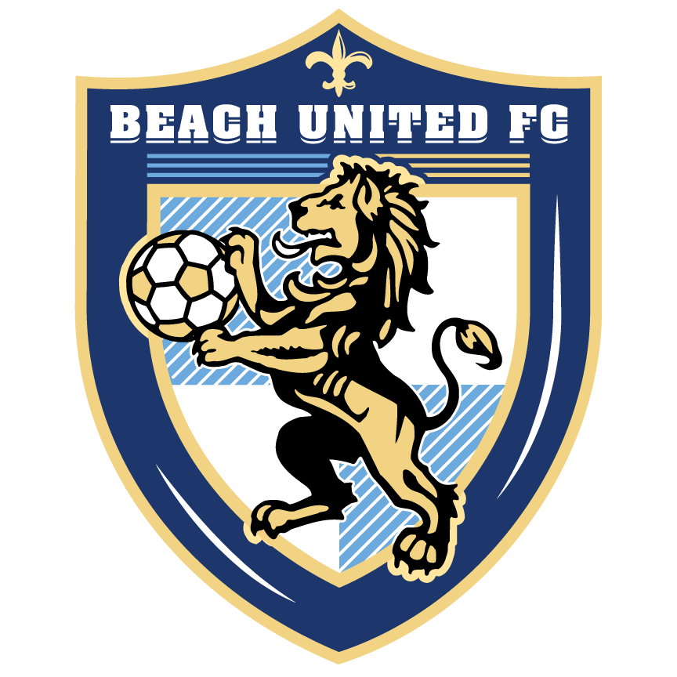

League fees: All league fees have to be paid on time. Those opting for a
payment plan must have the fees paid in full prior to September 10. Those with an
outstanding balance will not be eligible to train or play in games.
Tournament fees: Tournament fees will only be refunded in case of injury, serious illness or
death in the family. All tournament fees are due 3 weeks prior to the tournament. If a
player is only available one day of a two-day tournament, fees will be 50% of full cost.
Players who have not paid fees prior to tournament are not eligible to play.
Refunds: No refunds will be given for uniforms or initial commitment fee. League fees will only
be partially refunded in case of season ending injury, player moving out of town, or
in the event that a team is not available for the player.
Scholarships: Scholarship requests must be submitted to the board and will be reviewed
on a case by case basis. All scholarship recipients must do a minimum of 30 hours
of volunteer work for BUFC.
Commitment: Travel soccer is a big commitment. All players must attend all training and
games unless absence is approved by coach prior to training. Players must be on
the field ready to train 10 minutes prior to practice and 45 minutes prior to game
time.
Playing time: All players are not guaranteed equal playing time, this is at the coach’s discretion.
Playing time must be earned. Any concerns must be addressed after the 24-hour rule.
24-hour rule: After a game or training, all parents must wait 24 hours before bringing any
problems, questions or concerns to the attention of the coach, Director or administrator.
Alcohol and Tobacco: Alcohol and tobacco use are strictly prohibited on or around the soccer
field or parking lot during all games and training.
Team managers: All team managers are volunteering whose role it is to provide information to
parents and act as a link between the club, coach and parents. They cannot discuss
playing time or coaching decisions.
Field: All parents and team managers must stay off the field during training and games. If a
parent needs to speak with a coach, it must wait until after training or game is over.

If you have any questions or concerns, email doc@beachunitedfootballclub.com

